OBJECT-ORIENTED PROGRAMMING
Complete Interview Preparation Guide — A to Z
Java (Primary) · C++ (Comparisons & Additions)
On-Campus Fresher SDE Interviews
Covers: Java Basics · OOP Pillars · Constructors · Inheritance · Polymorphism · Abstraction · Interfaces · Encapsulation · Static · Final · Exceptions · Multithreading · Collections · Java 8 · Generics · Memory Management · Design Patterns · C++ Specifics

SECTION 1: Java Basics

1.1 Data Types
Q: What are the 8 primitive data types in Java?
Answer:
Type | Description | Range | Example
byte | 8-bit signed integer | -128 to 127 | byte b = 100;
short | 16-bit signed integer | -32,768 to 32,767 | short s = 1000;
int | 32-bit signed integer | ~±2.1 billion | int x = 42;
long | 64-bit signed integer | ~±9.2×10¹⁸ | long l = 100L;
float | 32-bit IEEE 754 float | ~6-7 decimal digits | float f = 3.14f;
double | 64-bit IEEE 754 float | ~15-16 decimal digits | double d = 3.14;
char | 16-bit Unicode character | 0 to 65535 | char c = 'A';
boolean | true/false | true or false | boolean b = true;

C++ C++ has same primitives + unsigned variants (unsigned int, unsigned long). Java has NO unsigned types except char.

1.2 Type Casting & Promotion
Q: What is implicit (widening) vs explicit (narrowing) casting?
Answer:
Widening (implicit): byte → short → int → long → float → double. No data loss. Automatic.
Narrowing (explicit): double → float → long → int → short → byte. Possible data loss. Must cast manually.

int i = 100;
long l = i; // widening — automatic
double d = l; // widening — automatic

double x = 9.99;
int y = (int) x; // narrowing — explicit cast, y = 9 (truncated)

// Type promotion in expressions
byte a = 10, b = 20;
// byte c = a + b; // ERROR! a+b promotes to int
byte c = (byte)(a + b); // explicit narrowing needed

1.3 Strings, StringBuilder, StringBuffer
Q: What is the difference between String, StringBuilder, and StringBuffer?
Answer:
Class | Key Property | When to Use
String | Immutable. Stored in String Pool. Thread-safe by design. | String s = "hello"; s += " world"; // creates NEW object
StringBuilder | Mutable. NOT thread-safe. Faster than StringBuffer. | sb.append("hi").append(123); // in-place modification
StringBuffer | Mutable. Thread-safe (synchronised methods). Slower. | Use in multi-threaded code requiring shared buffer

// String immutability — IMPORTANT interview point
String s1 = "hello";
String s2 = "hello";
System.out.println(s1 == s2); // true — same pool reference
String s3 = new String("hello");
System.out.println(s1 == s3); // false — different heap object
System.out.println(s1.equals(s3)); // true — same content

// StringBuilder for concatenation in loops — O(n) vs O(n^2)
StringBuilder sb = new StringBuilder();
for (int i = 0; i < 1000; i++) sb.append(i);
String result = sb.toString();

1.4 Arrays
Q: How are arrays different in Java vs C++?
Answer:

// Java — array is an OBJECT on the heap
int[] arr = new int[5]; // heap allocation
int[] arr2 = {1, 2, 3, 4, 5}; // array literal
System.out.println(arr.length); // built-in length property
// ArrayIndexOutOfBoundsException on out-of-range access

// 2D array
int[][] matrix = new int[3][4];
int[][] jagged = new int[3][]; // rows can have different lengths

C++ C++ arrays: int arr[5]; // stack allocated. No bounds checking. arr is just a pointer. Use std::vector<int> for dynamic size (equivalent to Java ArrayList<Integer>).

SECTION 2: OOP — The Four Pillars

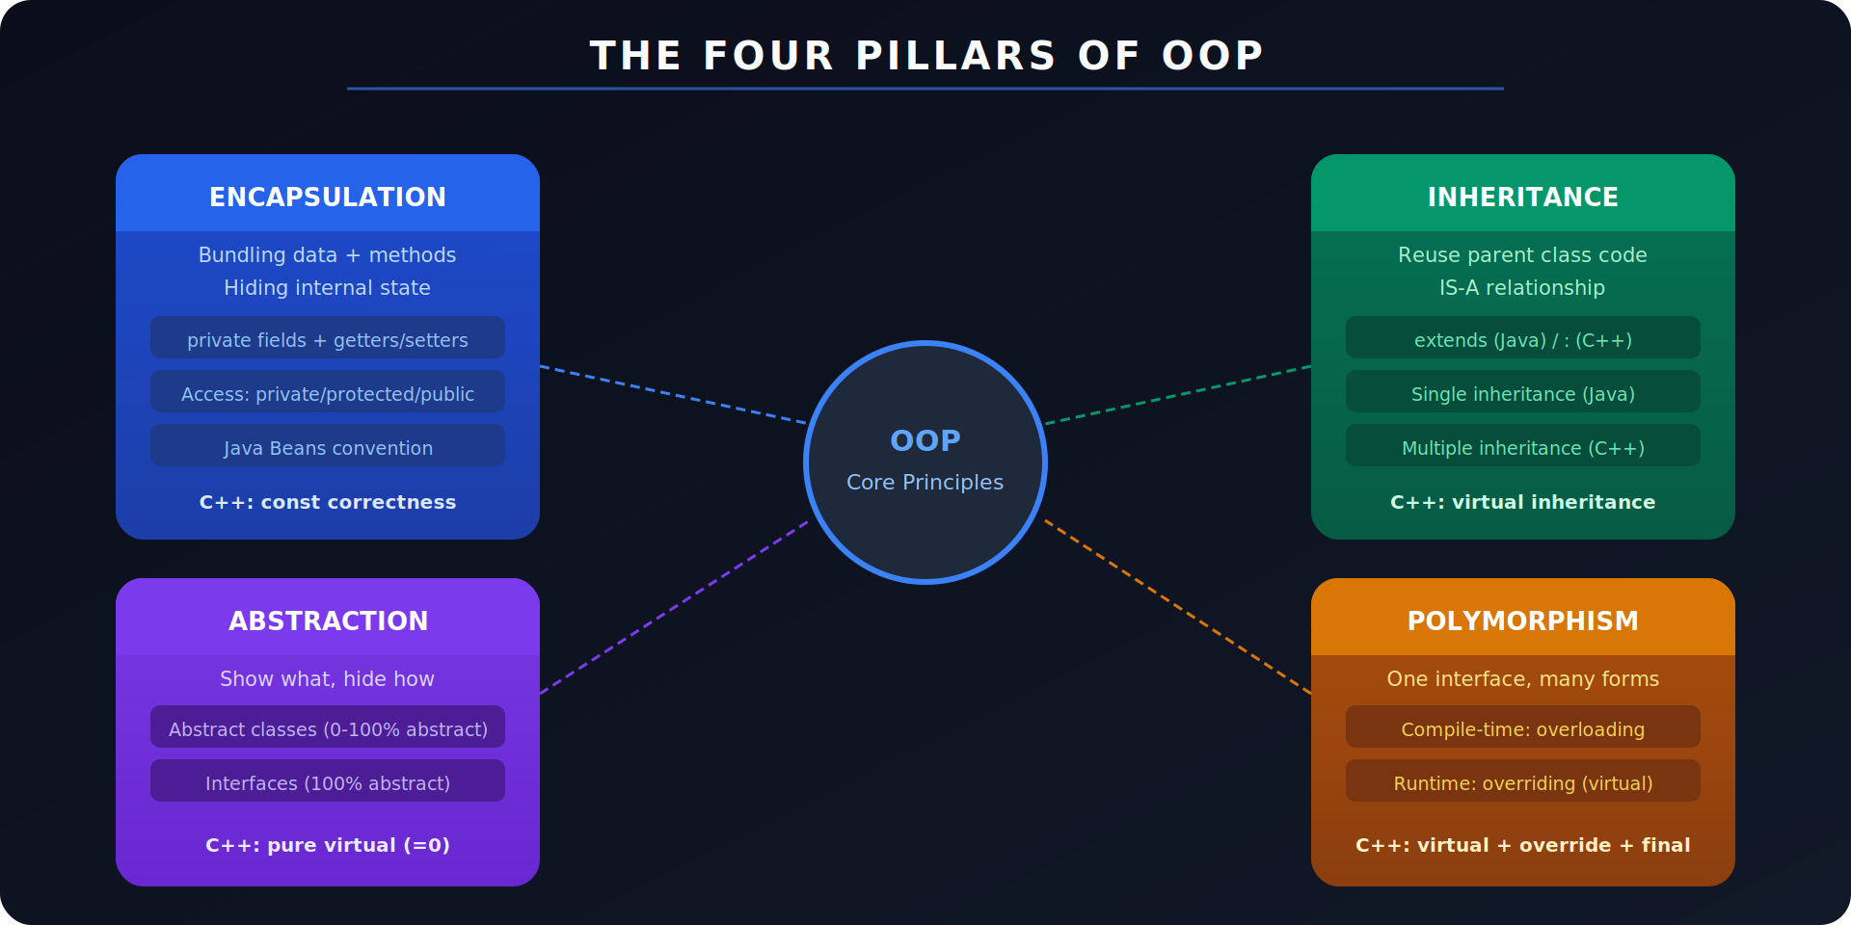
Figure 1: The Four Pillars of OOP — Encapsulation, Abstraction, Inheritance, Polymorphism

2.1 Encapsulation
Q: What is encapsulation? Why is it important?
Answer:
Definition: Bundling data (fields) and methods that operate on that data within a single unit (class), and restricting direct access to some components via access modifiers.
Benefits: (1) Data hiding — prevent invalid states. (2) Flexibility — change internal implementation without breaking external code. (3) Maintainability — clear public API.

public class BankAccount {
private double balance; // private — cannot be accessed directly
private String accountId;

public double getBalance() { // controlled read access
return balance;
}

public void deposit(double amount) { // controlled write with validation
if (amount <= 0) throw new IllegalArgumentException("Amount must be positive");
balance += amount;
}
// No setter for accountId — immutable after construction
}

C++ C++: same access modifiers (private, protected, public). Add const correctness: const methods cannot modify object state: double getBalance() const { return balance; }

2.2 Abstraction
Q: What is abstraction? How is it achieved in Java?
Answer:
Definition: Hiding implementation details and exposing only the necessary interface. Show WHAT an object does, not HOW it does it.
Two mechanisms in Java:
- Abstract classes: 0% to 99% abstract. Can have fields, constructors, concrete methods. Use when subclasses share common state/behaviour.
- Interfaces: 100% abstract (before Java 8). Define a contract. A class can implement multiple interfaces — Java's solution to multiple inheritance.

// Abstract class
abstract class Shape {
protected String colour; // shared state
Shape(String c) { colour = c; } // constructor
abstract double area(); // abstract method — must override
void printColour() { System.out.println(colour); } // concrete method
}

// Interface
interface Drawable {
void draw(); // implicitly public abstract
default void erase() { System.out.println("Erasing"); } // Java 8 default
static Drawable noop() { return () -> {}; } // Java 8 static
}

class Circle extends Shape implements Drawable {
private double radius;
Circle(double r) { super("red"); radius = r; }
@Override public double area() { return Math.PI * radius * radius; }
@Override public void draw() { System.out.println("Drawing circle"); }
}

C++ C++ pure virtual = abstract: virtual double area() = 0; A class with any pure virtual method is abstract. No interface keyword — use abstract class with all pure virtuals.

2.3 Inheritance
Q: Explain inheritance with types. Why does Java not support multiple inheritance?
Answer:
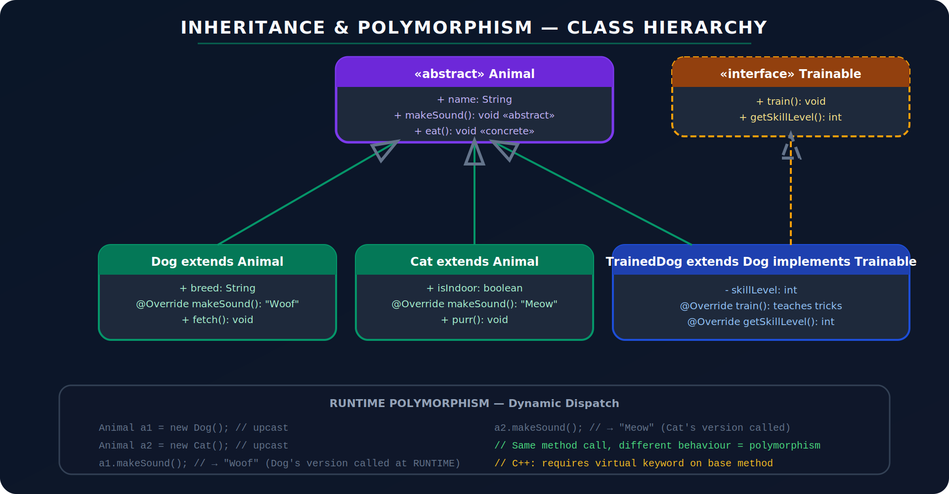
Figure 2: Inheritance Hierarchy — Animal → Dog/Cat → TrainedDog implements Trainable
Types of inheritance:
Type | Description | Example
Single | One parent, one child | Dog extends Animal
Multi-level | Chain: A → B → C | TrainedDog extends Dog extends Animal
Hierarchical | One parent, multiple children | Dog, Cat both extend Animal
Multiple | Two+ parents — NOT in Java | Java uses interfaces instead
Hybrid | Mix of above — NOT in Java directly | Via interfaces
Why no multiple class inheritance in Java? The Diamond Problem. If class C extends both A and B, and both A and B define method foo(), which version does C inherit? Ambiguity. Java solves this by allowing multiple interface implementation (since interfaces have no state, the conflict is resolved by the implementing class).
C++ C++ allows multiple inheritance: class C : public A, public B {}. Diamond problem solved via virtual inheritance: class A : virtual public Base {};

2.4 Polymorphism
Q: Explain compile-time vs runtime polymorphism with examples.
Answer:
Type | Mechanism | When Resolved | Example
Compile-time (Static) | Method Overloading | Resolved at compile time based on method signature | add(int,int) vs add(double,double)
Runtime (Dynamic) | Method Overriding | Resolved at runtime based on actual object type | Animal ref → Dog.makeSound()

// Compile-time polymorphism — Overloading
class Calculator {
int add(int a, int b) { return a + b; }
double add(double a, double b) { return a + b; } // different params
int add(int a, int b, int c) { return a + b + c; } // different arity
}

// Runtime polymorphism — Overriding + Upcasting
Animal a = new Dog(); // reference type: Animal, object type: Dog
a.makeSound(); // calls Dog.makeSound() — decided at RUNTIME
// a.fetch(); // COMPILE ERROR — Animal ref doesn't know fetch()

// instanceof check before downcast
if (a instanceof Dog d) { // Java 16+ pattern matching
d.fetch();
}

C++ C++: runtime polymorphism REQUIRES 'virtual' keyword on base method. Without virtual, base class method is called (static dispatch). Java methods are virtual by default.

SECTION 3: Constructors, Keywords & Class Members

3.1 Constructors & Overloading
Q: What are the constructor types? What is constructor chaining?
Answer:

class Person {
private String name;
private int age;

// Default constructor (compiler adds if none defined)
Person() { this("Unknown", 0); } // constructor chaining via this()

// Parameterised constructor
Person(String name, int age) {
this.name = name; // 'this' disambiguates field vs param
this.age = age;
}

// Copy constructor (Java — manual, no built-in)
Person(Person other) {
this.name = other.name;
this.age = other.age;
}
}

class Employee extends Person {
private String company;
Employee(String name, int age, String company) {
super(name, age); // must be FIRST line — calls parent constructor
this.company = company;
}
}

C++ C++ has 3 special constructors: Default: Person() {}, Copy: Person(const Person& other) {}, Move: Person(Person&& other) {}. Also Destructor: ~Person() { // release resources }. Rule of 3/5: if you define any of destructor/copy/move, define all.

3.2 this and super Keywords
Q: Explain 'this' and 'super' with all their uses.
Answer:
Usage | Purpose | Example
this.field | Refer to current object's field (vs local variable) | this.name = name;
this() | Call another constructor of same class (must be first line) | this("default", 0);
this (as ref) | Pass current object as argument | list.add(this);
super.method() | Call parent class method | super.toString()
super() | Call parent constructor (must be first line) | super(name, age);
super.field | Access parent field if shadowed | super.colour

3.3 Static Members & Blocks
Q: What is static? What is a static block?
Answer:

class Counter {
private static int count = 0; // shared across ALL instances
private int id;

// Static block — runs ONCE when class is first loaded
static {
System.out.println("Counter class loaded");
count = 10; // initialise static state
}

Counter() { id = ++count; }

public static int getCount() { return count; } // static method
// Cannot use 'this' or instance fields inside static methods
}

// Static methods called on CLASS, not instance
Counter.getCount();
Math.abs(-5); // Math.abs is static

C++ C++: static data member must be defined outside the class: int Counter::count = 0; Static methods same concept. No static blocks — use static member initialization or anonymous namespace.

3.4 Final Keyword
Q: What are the three uses of 'final' in Java?
Answer:
Usage | Effect | Example
final variable | Constant — cannot be reassigned after initialisation | final int MAX = 100;
final method | Cannot be overridden in subclasses | final void reset() {}
final class | Cannot be subclassed (e.g., String, Integer) | public final class String
C++ C++ equivalents: const variable, final method → override + final specifier in C++11: void makeSound() final; , sealed class → final class: class Dog final : public Animal {};

3.5 Access Modifiers
Q: Explain all four access modifiers in Java.
Answer:
Modifier | Scope | Notes
private | Class only | Can't access outside the class
default (no keyword) | Package | Accessible within same package only
protected | Package + subclasses | Subclasses in any package can access
public | Everywhere | No restriction
C++ C++ has private, protected, public (same meaning). Default is private for class, public for struct. No package concept — use namespaces. Friend keyword grants specific external class/function access.

SECTION 4: Exception Handling

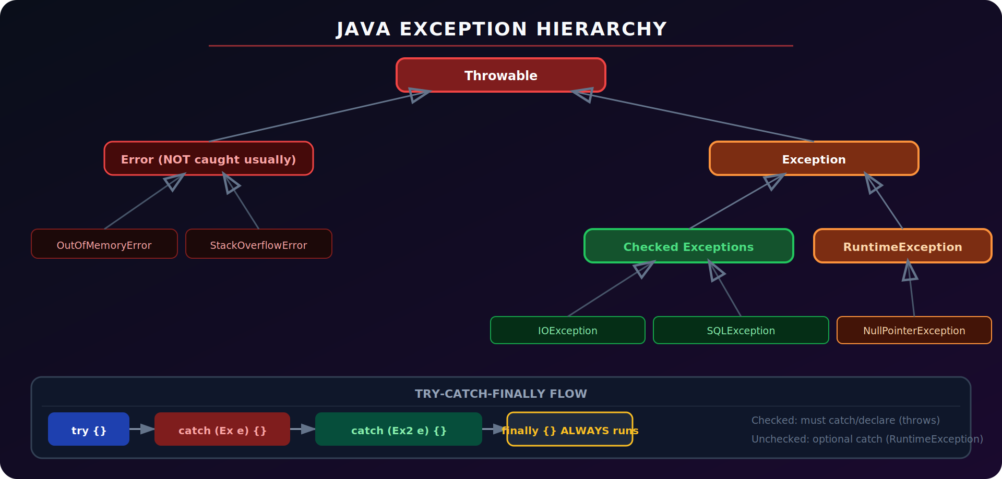
Figure 3: Java Exception Hierarchy — Throwable → Error / Exception → Checked / Unchecked

4.1 Checked vs Unchecked Exceptions
Q: What is the difference between checked and unchecked exceptions?
Answer:
Type | Hierarchy | Requirement | Examples
Checked | Extends Exception (not RuntimeException) | Must be caught or declared with 'throws' | IOException, SQLException, FileNotFoundException
Unchecked | Extends RuntimeException | Optional to catch | NullPointerException, ArrayIndexOutOfBoundsException, IllegalArgumentException
Error | Extends Error | Never catch — unrecoverable JVM problems | OutOfMemoryError, StackOverflowError

4.2 try-catch-finally & Custom Exceptions
Q: Show try-catch-finally and how to create a custom exception.
Answer:

// Custom checked exception
class InsufficientFundsException extends Exception {
private double amount;
InsufficientFundsException(double amount) {
super("Insufficient funds: need " + amount);
this.amount = amount;
}
public double getAmount() { return amount; }
}

// Using try-catch-finally
public void withdraw(double amount) throws InsufficientFundsException {
if (amount > balance) throw new InsufficientFundsException(amount);
balance -= amount;
}

try {
account.withdraw(1000);
} catch (InsufficientFundsException e) {
System.out.println(e.getMessage());
} catch (Exception e) { // catch broader AFTER specific
e.printStackTrace();
} finally {
System.out.println("Always runs — close resources here");
}

// try-with-resources (Java 7+) — auto-closes Autocloseable
try (BufferedReader br = new BufferedReader(new FileReader("file.txt"))) {
String line = br.readLine();
} // br.close() called automatically even if exception thrown

4.3 throw vs throws
Q: What is the difference between throw and throws?
Answer:
Keyword | Usage | Example
throw | Used inside method body to actually throw an exception object | throw new NullPointerException("Name is null");
throws | Used in method signature to declare that this method MAY throw | void read() throws IOException, SQLException

SECTION 5: Multithreading & Concurrency

5.1 Creating Threads
Q: What are the two ways to create a thread in Java? Which is preferred?
Answer:

// Way 1: Extend Thread class
class MyThread extends Thread {
@Override
public void run() { System.out.println("Thread: " + getName()); }
}
new MyThread().start(); // start() creates new thread; run() would run on current

// Way 2: Implement Runnable (PREFERRED — doesn't waste extends)
class MyTask implements Runnable {
@Override
public void run() { System.out.println("Task running"); }
}
new Thread(new MyTask()).start();

// Way 3: Lambda (Java 8+) — most concise
new Thread(() -> System.out.println("Lambda thread")).start();

// Way 4: Executor Framework (production preferred)
ExecutorService pool = Executors.newFixedThreadPool(4);
pool.submit(() -> System.out.println("Pool thread"));
pool.shutdown();

5.2 Thread Lifecycle
Q: Draw/explain the Thread lifecycle.
Answer:
State | Description | Trigger
NEW | Thread object created, start() not called yet | Thread t = new Thread(...)
RUNNABLE | start() called. Ready to run or running (JVM/OS decides) | t.start()
BLOCKED | Waiting to acquire a monitor lock (synchronised block) | Trying to enter synchronised
WAITING | Waiting indefinitely — needs notify() to wake | object.wait()
TIMED_WAITING | Waiting for specified time | Thread.sleep(1000), join(100)
TERMINATED | run() completed or exception thrown | Method returned

5.3 Synchronisation
Q: What is a race condition and how does synchronised fix it?
Answer:

// Race condition example — NOT thread-safe
class Counter { int count = 0; }
counter.count++; // read → increment → write: NOT atomic. Two threads can interleave.

// Fix 1: synchronized method
class SafeCounter {
private int count = 0;
public synchronized void increment() { count++; } // only 1 thread at a time
public synchronized int get() { return count; }
}

// Fix 2: synchronized block (finer granularity)
public void increment() {
synchronized(this) { // acquire lock on 'this'
count++;
}
}

// Fix 3: AtomicInteger (lock-free, fastest for single value)
AtomicInteger count = new AtomicInteger(0);
count.incrementAndGet(); // atomic CAS operation

// wait/notify — thread communication
synchronized(sharedObj) {
while (!condition) sharedObj.wait(); // releases lock, waits
// ... do work ...
sharedObj.notifyAll(); // wake all waiting threads
}

SECTION 6: Java Collections Framework

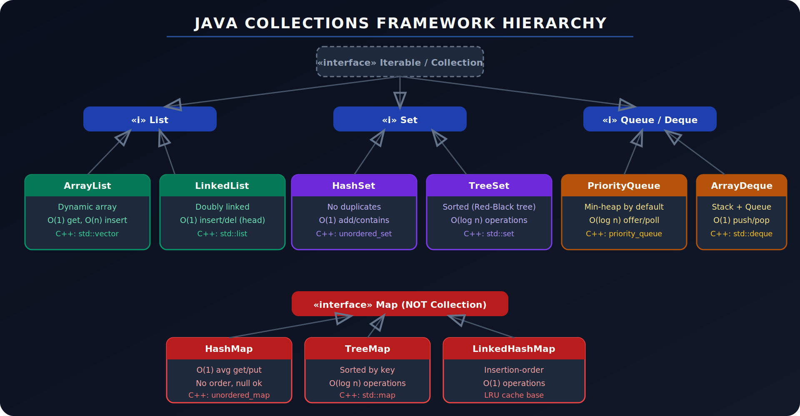
Figure 4: Java Collections Hierarchy — List, Set, Queue, Map

6.1 List — ArrayList vs LinkedList
Q: When would you use ArrayList vs LinkedList?
Answer:
Class | Characteristics | Use When
ArrayList | O(1) random access by index. O(n) insert/delete in middle. Backed by dynamic array. Cache-friendly. | Read-heavy operations, random access
LinkedList | O(n) random access. O(1) insert/delete at head/tail. Doubly-linked. Not cache-friendly. | Frequent insertions/deletions at ends, implementing Queue/Deque
C++ std::vector = ArrayList (dynamic array). std::list = LinkedList (doubly linked). std::deque = double-ended queue backed by array segments.

6.2 Set & Map
Q: Explain HashSet vs TreeSet, and HashMap vs TreeMap.
Answer:
Class | Properties | Notes
HashSet | O(1) add/contains/remove. No order. Backed by HashMap. Allows null. | HashSet<String> set = new HashSet<>();
TreeSet | O(log n). Sorted order (natural or Comparator). No null. | TreeSet<Integer> sorted = new TreeSet<>();
LinkedHashSet | O(1). Maintains insertion order. | Predictable iteration order
HashMap | O(1) avg. No key order. Allows 1 null key. | HashMap<String,Integer> map = new HashMap<>();
TreeMap | O(log n). Sorted by key. No null keys. | TreeMap for sorted iteration
LinkedHashMap | O(1). Insertion-order or access-order. | LRU cache implementation
ConcurrentHashMap | Thread-safe HashMap. Lock striping. O(1). | Multi-threaded access

6.3 Comparable vs Comparator
Q: What is the difference between Comparable and Comparator?
Answer:

// Comparable — natural ordering, implemented BY the class
class Student implements Comparable<Student> {
String name; int gpa;
@Override
public int compareTo(Student other) {
return Double.compare(this.gpa, other.gpa); // sort by GPA ascending
}
}
Collections.sort(students); // uses compareTo

// Comparator — external ordering, passed separately
Comparator<Student> byName = (s1, s2) -> s1.name.compareTo(s2.name);
students.sort(byName);

// Chaining comparators
students.sort(Comparator.comparing((Student s) -> s.gpa)
.thenComparing(s -> s.name));

SECTION 7: Java 8 Features

7.1 Lambda Expressions & Functional Interfaces
Q: What is a lambda expression and a functional interface?
Answer:
Functional Interface: An interface with exactly ONE abstract method (can have default/static). Annotated with @FunctionalInterface. Can be represented by a lambda.

@FunctionalInterface
interface MathOperation { int operate(int a, int b); }

// Traditional anonymous class
MathOperation add = new MathOperation() {
public int operate(int a, int b) { return a + b; }
};

// Lambda — concise replacement
MathOperation add = (a, b) -> a + b;
MathOperation square = (a, b) -> { int r = a * a; return r; };

// Built-in functional interfaces
Predicate<String> isLong = s -> s.length() > 5; // T → boolean
Function<String, Integer> len = String::length; // T → R
Consumer<String> print = System.out::println; // T → void
Supplier<List<String>> newList = ArrayList::new; // () → T
BiFunction<Integer,Integer,Integer> mul = (a,b) -> a*b;

7.2 Stream API
Q: Show common Stream API operations.
Answer:

List<String> names = List.of("Alice", "Bob", "Charlie", "Anna", "Brian");

// filter → map → collect
List<String> result = names.stream()
.filter(n -> n.startsWith("A")) // intermediate: keep A names
.map(String::toUpperCase) // intermediate: transform
.sorted() // intermediate: sort
.collect(Collectors.toList()); // terminal: materialise
// result: [ALICE, ANNA]

// reduce
int sum = IntStream.rangeClosed(1, 10).reduce(0, Integer::sum); // 55

// groupingBy
Map<Integer,List<String>> byLength = names.stream()
.collect(Collectors.groupingBy(String::length));

// Optional — avoids NullPointerException
Optional<String> first = names.stream().filter(n -> n.startsWith("Z")).findFirst();
String val = first.orElse("Not found"); // safe default
first.ifPresent(System.out::println); // only runs if present

SECTION 8: Java Memory Management

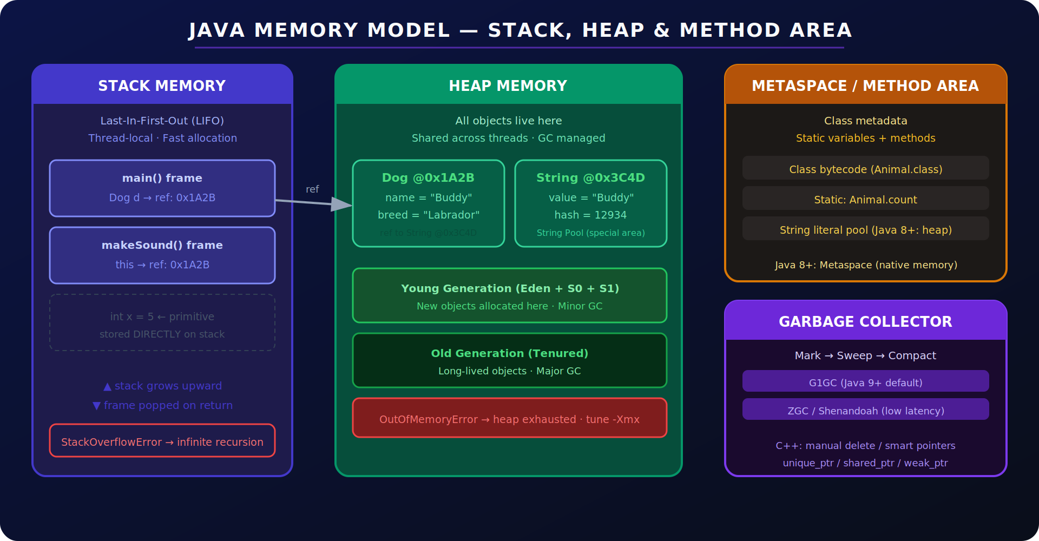
Figure 5: Java Memory Model — Stack, Heap, Metaspace, Garbage Collector

8.1 Stack vs Heap
Q: What is stored in Stack vs Heap memory?
Answer:
Area | Contents | Example
Stack | Primitive variables, object references (not objects), method call frames. Thread-local. LIFO. Fixed size per frame. | int x = 5 (value on stack), Dog d (reference on stack)
Heap | All objects (new Foo()). Strings. Arrays. Shared across threads. GC managed. | new Dog() → object body on heap
Metaspace (Java 8+) | Class metadata, bytecode, static variables, string pool (Java 7+ moved to heap). Native memory. | Class definitions, static int count
Stack overflow | Infinite recursion exhausts stack frames | StackOverflowError
Heap overflow | Too many objects, GC cannot free enough | OutOfMemoryError

8.2 Garbage Collection
Q: How does the Java Garbage Collector work?
Answer:
Mark & Sweep: (1) Mark: GC roots (stack refs, static refs) trace all reachable objects. (2) Sweep: unmarked objects freed. (3) Compact: move live objects together to defragment heap.
Generational GC: Young Generation (Eden + S0 + S1): new objects here. Most die young (infant mortality). Minor GC is fast. Old Generation (Tenured): objects that survived multiple minor GCs. Major GC is slower.
Modern collectors:
- G1GC (Java 9+ default): Region-based. Predictable pause times. Good for large heaps.
- ZGC: Sub-millisecond pauses. Concurrent. For latency-critical applications.

// Make object eligible for GC
Dog d = new Dog("Rex");
d = null; // reference removed — Dog eligible for GC
d = new Dog("Max"); // original Rex now unreachable

// finalize() — deprecated Java 9, removed Java 18
// Use Cleaner API or try-with-resources instead

// JVM flags for GC tuning
// -Xms512m (initial heap size)
// -Xmx2g (max heap size)
// -XX:+UseG1GC (use G1 collector)

C++ C++ has NO GC. Manual memory management: new allocates on heap, delete frees. Memory leak = forget to delete. Double-free = delete twice. Solution: RAII + smart pointers. unique_ptr auto-deletes when it goes out of scope. shared_ptr deletes when ref count hits 0. Destructor ~ClassName() called when object is destroyed.

SECTION 9: Advanced Topics

9.1 Generics & Wildcards
Q: What are generics and what is the difference between <T>, <? extends T>, <? super T>?
Answer:

// Generic class
class Box<T> {
private T value;
Box(T v) { value = v; }
T get() { return value; }
}
Box<Integer> intBox = new Box<>(42);
Box<String> strBox = new Box<>("hello");

// Generic method
<T extends Comparable<T>> T max(T a, T b) { return a.compareTo(b) > 0 ? a : b; }

// Wildcards
// <? extends T> — Upper bounded: read-only (producer). You can read T.
void printAll(List<? extends Number> list) { for (Number n : list) System.out.println(n); }

// <? super T> — Lower bounded: write-only (consumer). You can add T.
void addNumbers(List<? super Integer> list) { list.add(42); }

// PECS rule: Producer Extends, Consumer Super

9.2 Inner Classes & Enums
Q: What are the types of inner classes?
Answer:
Type | Description | Example
Static nested class | Declared static inside outer. No outer instance needed. Like a top-level class in a namespace. | class Outer { static class Inner {} }
Inner (non-static) | Has reference to outer instance. Can access outer fields. | class Outer { class Inner { outer.field } }
Local class | Defined inside a method. Scoped to method. | void method() { class Local {} }
Anonymous class | Unnamed class defined and instantiated inline. Old way before lambdas. | Runnable r = new Runnable() { public void run(){} };

9.3 Annotations
Q: What are common Java annotations and what do they do?
Answer:
Annotation | Purpose | Note
@Override | Compiler checks that method actually overrides parent | Prevents typo bugs in method name
@Deprecated | Marks method/class as outdated | Generates compiler warning on use
@SuppressWarnings | Suppresses specific compiler warnings | @SuppressWarnings("unchecked")
@FunctionalInterface | Marks interface as having exactly one abstract method | Compile error if >1 abstract method
@SafeVarargs | Suppresses heap pollution warning for varargs | For generic varargs methods

9.4 Reflection API
Q: What is reflection? When would you use it?
Answer:
Reflection: The ability to inspect and modify class structure and behaviour at runtime — get class name, list methods/fields, invoke methods, create instances — without knowing the type at compile time.

Class<?> clazz = Class.forName("com.example.Dog");
Method[] methods = clazz.getDeclaredMethods();
Object dog = clazz.getDeclaredConstructor(String.class).newInstance("Rex");
Method makeSound = clazz.getMethod("makeSound");
makeSound.invoke(dog); // calls Dog.makeSound() at runtime

Use cases: Frameworks (Spring DI, JUnit, Hibernate ORM), serialisation libraries, plugin systems, debuggers. Avoid in normal application code — breaks encapsulation, slower, not type-safe.

SECTION 10: Design Patterns

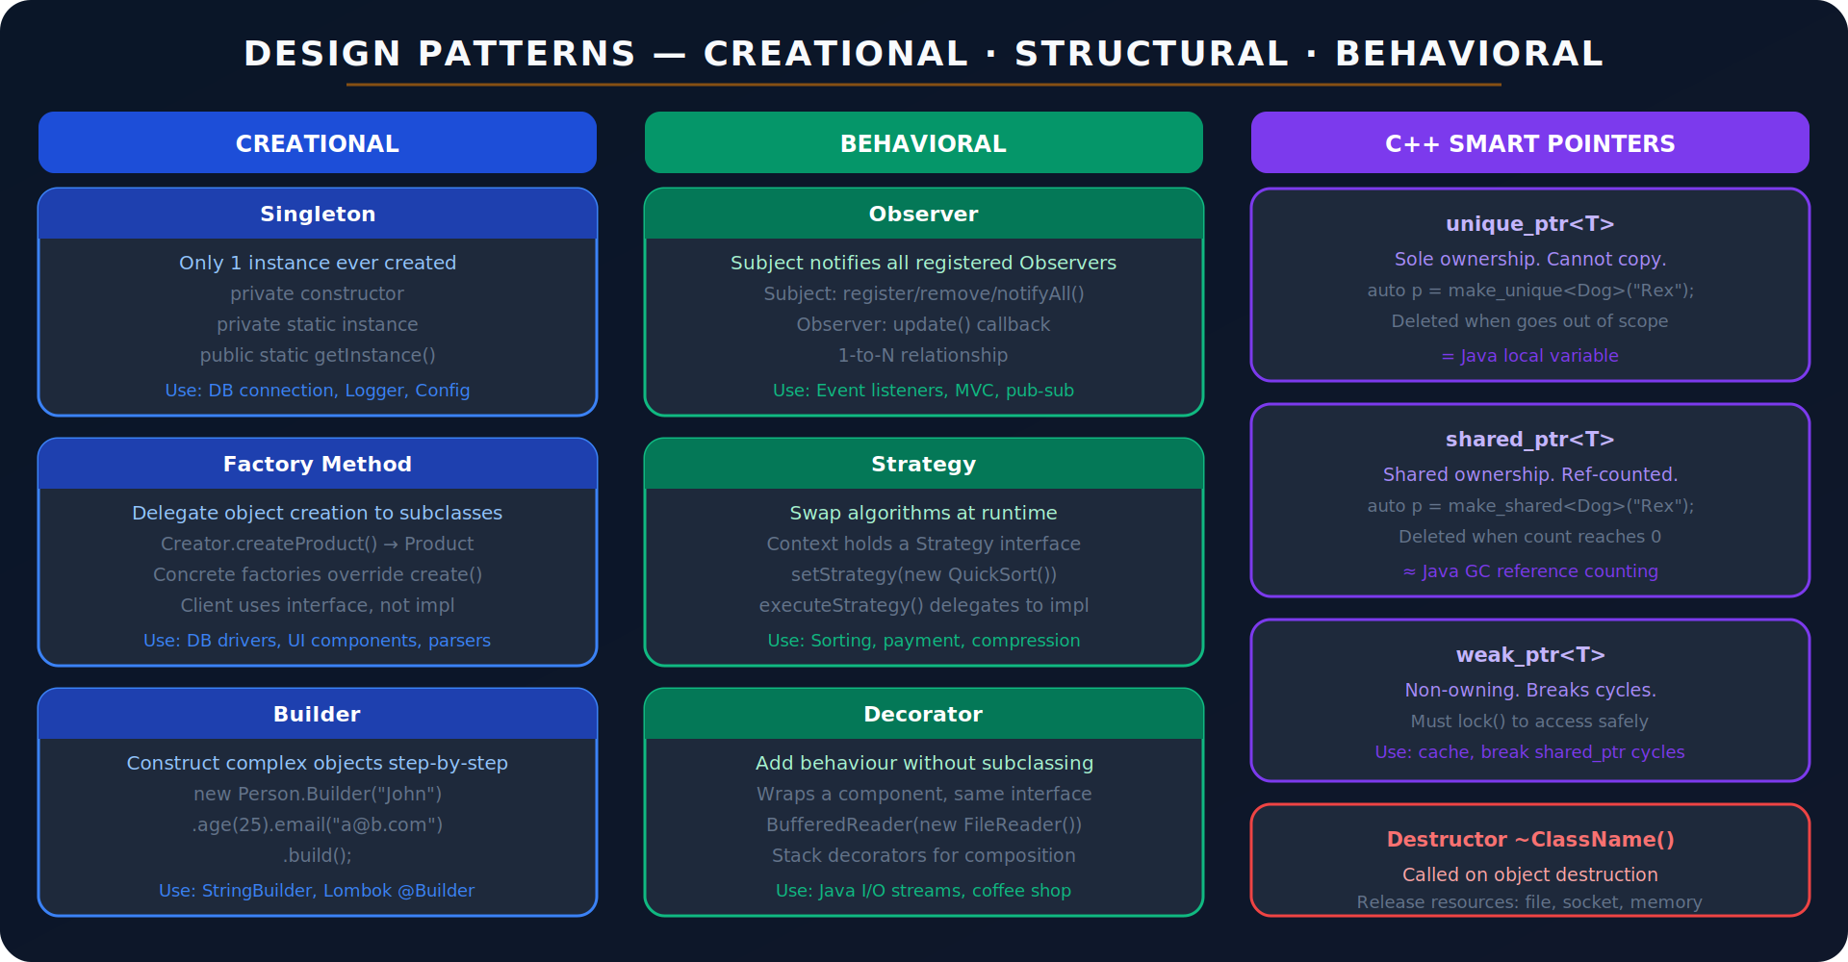
Figure 6: Design Patterns — Creational, Behavioral, C++ Smart Pointers & Destructor

10.1 Singleton
Q: Implement thread-safe Singleton in Java.
Answer:

// Double-checked locking — thread-safe + lazy init
public class DatabaseConnection {
private static volatile DatabaseConnection instance; // volatile prevents reordering

private DatabaseConnection() {} // private constructor

public static DatabaseConnection getInstance() {
if (instance == null) { // first check (no lock)
synchronized (DatabaseConnection.class) {
if (instance == null) { // second check (with lock)
instance = new DatabaseConnection();
}
}
}
return instance;
}
}

// Better: Bill Pugh Singleton (class loading is thread-safe)
public class Singleton {
private Singleton() {}
private static class Holder { static final Singleton INSTANCE = new Singleton(); }
public static Singleton getInstance() { return Holder.INSTANCE; }
}

10.2 Factory Pattern
Q: Implement the Factory pattern.
Answer:

interface Animal { void makeSound(); }
class Dog implements Animal { public void makeSound() { System.out.println("Woof"); } }
class Cat implements Animal { public void makeSound() { System.out.println("Meow"); } }

class AnimalFactory {
public static Animal create(String type) {
return switch (type.toLowerCase()) {
case "dog" -> new Dog();
case "cat" -> new Cat();
default -> throw new IllegalArgumentException("Unknown: " + type);
};
}
}

Animal a = AnimalFactory.create("dog");
a.makeSound(); // Woof — client doesn't know it's a Dog

10.3 Observer Pattern
Q: Implement Observer pattern.
Answer:

interface Observer { void update(String event); }

class EventManager {
private List<Observer> listeners = new ArrayList<>();
public void subscribe(Observer o) { listeners.add(o); }
public void unsubscribe(Observer o) { listeners.remove(o); }
public void notifyAll(String event) { listeners.forEach(o -> o.update(event)); }
}

class Logger implements Observer {
public void update(String event) { System.out.println("LOG: " + event); }
}
class EmailNotifier implements Observer {
public void update(String event) { System.out.println("EMAIL: " + event); }
}

EventManager em = new EventManager();
em.subscribe(new Logger());
em.subscribe(new EmailNotifier());
em.notifyAll("User registered"); // both get notified

10.4 Strategy Pattern
Q: Implement Strategy pattern.
Answer:

interface SortStrategy { void sort(int[] arr); }
class BubbleSort implements SortStrategy {
public void sort(int[] arr) { /* bubble sort logic */ }
}
class QuickSort implements SortStrategy {
public void sort(int[] arr) { /* quicksort logic */ }
}

class Sorter {
private SortStrategy strategy;
public void setStrategy(SortStrategy s) { strategy = s; }
public void sort(int[] arr) { strategy.sort(arr); } // delegate
}

Sorter sorter = new Sorter();
sorter.setStrategy(new QuickSort()); // swap algorithm at runtime
sorter.sort(data);

SECTION 11: C++ Specific Concepts

11.1 Pointers & References
Q: Explain pointers vs references in C++. Compare to Java references.
Answer:

// C++ Pointer — stores memory address, can be null, can be reassigned
int x = 10;
int* ptr = &x; // ptr stores address of x
*ptr = 20; // dereference: x is now 20
ptr = nullptr; // can be null

// C++ Reference — alias for existing variable, cannot be null, cannot be reassigned
int& ref = x; // ref IS x (same memory location)
ref = 30; // x is now 30
// int& r2; // ERROR — must initialise reference

// Java reference — like a C++ pointer but managed, no arithmetic, no null deref crash
Dog d = new Dog(); // d is a reference (like C++ Dog* d = new Dog();)
d = null; // like ptr = nullptr; but no UB — NullPointerException on deref

11.2 Destructors & RAII
Q: What is a destructor? What is RAII?
Answer:
Destructor: Called automatically when an object goes out of scope (stack) or when delete is called (heap). Used to release resources — file handles, memory, network connections.
RAII (Resource Acquisition Is Initialisation): Resources are acquired in constructor and released in destructor. Guarantees cleanup even if exception thrown — deterministic unlike Java's finalizer/GC.

class FileHandler {
FILE* file;
public:
FileHandler(const char* path) {
file = fopen(path, "r"); // acquire resource in constructor
if (!file) throw std::runtime_error("Cannot open file");
}
~FileHandler() { // destructor — called automatically
if (file) fclose(file); // release resource
std::cout << "File closed\n";
}
// ... read methods ...
};

void process() {
FileHandler fh("data.txt"); // constructor: file opened
// ... use file ...
// If exception thrown here, destructor STILL called
} // destructor called here: file closed automatically

11.3 Virtual Functions & Vtable
Q: How does C++ implement runtime polymorphism? What is a vtable?
Answer:
virtual keyword: Required in C++ for runtime polymorphism. Without virtual, base class method is called (static dispatch). Java methods are virtual by default.
Vtable (Virtual dispatch table): Compiler creates a table of function pointers for each class with virtual methods. Each object has a vptr pointing to its class's vtable. At runtime, method call is resolved by looking up the vtable — O(1) overhead.

class Animal {
public:
virtual void makeSound() { cout << "..."; } // virtual
virtual ~Animal() {} // ALWAYS make destructor virtual!
};

class Dog : public Animal {
public:
void makeSound() override { cout << "Woof"; } // override specifier (C++11)
// override = Java @Override — compile error if not actually overriding
};

Animal* a = new Dog();
a->makeSound(); // "Woof" — vtable lookup finds Dog::makeSound
delete a; // calls Dog destructor THEN Animal destructor (virtual dtor!)

// Without virtual on makeSound:
// a->makeSound() would call Animal::makeSound() — static dispatch

SECTION 12: Top Interview Questions & Tricky Concepts

12.1 Classic Tricky Questions
Q: What is the difference between == and .equals() in Java?
Answer:
==: Compares references (memory addresses) for objects. Compares values for primitives.
.equals(): Compares content. Object.equals() defaults to ==, but String, Integer, etc. override it to compare values.

String s1 = "hello"; String s2 = "hello";
s1 == s2 // true (same String pool object)
s1 = new String("hello");
s1 == s2 // false (different heap objects)
s1.equals(s2) // true (same content)
Integer a = 127; Integer b = 127; a == b // true (cache -128 to 127)
Integer c = 128; Integer d = 128; c == d // false (outside cache)

Q: Can we override a static method? What is method hiding?
Answer:
No, static methods cannot be overridden. They belong to the class, not the instance. If a subclass defines a static method with the same signature, it hides the parent's method — it does NOT override it. No dynamic dispatch.

class Parent { static void greet() { System.out.println("Parent"); } }
class Child extends Parent { static void greet() { System.out.println("Child"); } }

Parent p = new Child();
p.greet(); // 'Parent' — static binding, no vtable
Child c = new Child();
c.greet(); // 'Child'

Q: What is the difference between abstract class and interface? When to use which?
Answer:
Property | Abstract Class | Interface
Can have constructor | Yes | No
Can have instance fields | Yes | No (only static final constants)
Can have concrete methods | Yes | Yes (default/static, Java 8+)
Multiple inheritance | No (single extends) | Yes (multiple implements)
Default access of methods | Can vary | public abstract
Use when | Shared code + state among related classes | Define contract for unrelated classes
Example | Vehicle (shared fields: speed, fuel) | Serializable, Comparable, Runnable

Q: What happens if you don't call super() in a subclass constructor?
Answer:
Java compiler automatically inserts super() as the first line if the parent has a no-arg constructor. If the parent has NO no-arg constructor, it is a compile error — you MUST explicitly call the appropriate super() constructor.

Q: What is covariant return type?
Answer:
In Java 5+, an overriding method can return a subtype of the parent's return type. Example: parent returns Animal, override can return Dog (since Dog IS-A Animal). This is covariant return type.

Q: Explain 'is-a' vs 'has-a' relationships.
Answer:
Relationship | Mechanism | Example
is-a (Inheritance) | Use extends/implements | Dog IS-A Animal → class Dog extends Animal
has-a (Composition) | Hold a reference as a field | Car HAS-A Engine → class Car { Engine engine; }
Prefer composition over inheritance | More flexible, avoids tight coupling | Strategy pattern uses composition

12.2 C++ vs Java Quick Comparison
Feature | Java | C++
Memory management | GC (automatic) | Manual (new/delete) or smart pointers
Multiple inheritance | Via interfaces only | Full class + interface
Runtime polymorphism | Default (all methods virtual) | Requires 'virtual' keyword
Pointers | No (managed references) | Yes (raw + smart pointers)
Destructor | finalize() (deprecated), GC | ~ClassName() — deterministic RAII
String | Immutable String class | std::string (mutable)
Default access | package-private | private for class, public for struct
Operator overloading | No | Yes
Templates/Generics | Generics (type erasure at runtime) | Templates (compile-time code gen)
Exception specification | Checked + unchecked | noexcept specifier

SECTION 13: Quick Reference Cheat Sheet

13.1 OOP Keywords — Java
Keyword | Meaning
extends | Inherit from a class (single only)
implements | Implement one or more interfaces
abstract | Class with abstract methods OR abstract method declaration
interface | Pure contract — default methods allowed since Java 8
final | Variable: constant · Method: no override · Class: no extend
static | Belongs to class, not instance
this | Current object reference / call another constructor
super | Parent class reference / call parent constructor
instanceof | Runtime type check: if (a instanceof Dog d)
new | Allocate object on heap
synchronized | Mutual exclusion lock on method or block
volatile | Ensures visibility across threads (no caching)
transient | Exclude field from serialisation

13.2 OOP Rapid-Fire One-Liners
Question | Answer
Overloading vs Overriding | Overloading: same name, different params, compile-time. Overriding: same signature, subclass, runtime.
Abstract class vs Interface | Abstract: state + code + 1 parent. Interface: contract + no state + multiple allowed.
== vs equals | ==: reference equality. equals(): content equality (if overridden).
Stack vs Heap | Stack: primitives + refs + frames, thread-local. Heap: objects, shared, GC.
String immutability | Strings cannot be modified. Any 'change' creates a new object.
Why no multiple inheritance Java | Diamond problem. Use interfaces instead.
Singleton thread-safe way | Bill Pugh (Holder class) or double-checked locking with volatile.
PECS rule | Producer Extends, Consumer Super — for generic wildcards.
ArrayList vs LinkedList | ArrayList: O(1) get. LinkedList: O(1) insert at head/tail.
HashMap internal working | Array of buckets + linked list/tree (Java 8+). hashCode() → bucket, equals() → exact key.
Checked vs Unchecked | Checked: must handle (IOException). Unchecked: optional (NPE, RuntimeException).
C++ virtual keyword | Required for runtime polymorphism. Java: all methods virtual by default.
C++ destructor rule | Always make base class destructor virtual if using polymorphism.
RAII | Constructor acquires, destructor releases — deterministic vs Java GC.

All the best! Crack that interview! 🚀
OOP Complete Interview Preparation Guide — Java + C++

